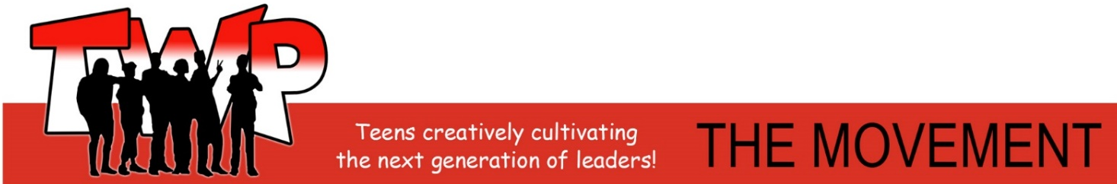
TWP – The Youth Movement | VCM Teen Center 700 E Olney Road, Norfolk, VA 23504 | P: 757-747-2679 |www.TWPTheMovement.org

Norfolk Police Department – Teens With A Purpose

Spring Break Mini Day Camp

RELEASE OF LIABILITY FORM

I, ________________________________ (print)

Parent/guardian

Do hereby give my son/daughter____________________________ permission

to attend the Norfolk Police Department –Teens With A Purpose

Spring Break Mini Day, on one of the following days, March 29, March 30, March 31, in

consideration of allowing him/her to participate in

the above named program, I voluntarily and knowingly release and discharge the

Norfolk Police Department, the City of Norfolk, Teens With A Purpose

and all Instructors in this program from all claims and liability arising out of his/her

participation in the Spring Break Mini Day Camp.

This hold harmless agreement is a testament to my understanding of the above.

Parent/Guardian’s Signature________________________________________.

Photo Release (not required)

Photo Release Agreement understand that the participant named above may be photographed and/or
audio and/or videotaped as part of the Spring Break Mini Camp mentioned above. I agree to allow TWP – The Youth Movement and Norfolk Police Department, The City of Norfolk to use said photographs and/or audio and/or videotapes in publications, media campaigns, educational, arts and/or safety purposes. I further waive any remuneration for displaying, publishing and/or printing such photographs.

Parent/Guardian’s Signature________________________________________.

